The Passover Timeline

Exodus 12:29-36

I want to look at the events during the Passover and put it all together in order of events. And then compare this to the actual fulfillment of the Passover when Jesus Christ became the Passover Lamb who died for the sins of the whole world.

Instruction of the Passover Given

- In the 10th day of the first month, take every man a lamb. The lamb must be without blemish. A male of the 1st year. Take it from the sheep or the goats.

- Keep the lamb up until the 14th day of the first month. Whole assembly of the congregation of Israel shall kill it. It shall be killed in the evening.

- Take the blood of the passover lamb and strike it on the two side posts and on the upper door post of the houses. The blood is a token upon the houses. When God sees the blood, He will pass over you. The plague shall not be upon you to destroy you. God will smite the land of Egypt. Take a bunch of hyssop and dip it in the blood that is in the bason. Strike the lintel and the two side posts with the blood in the bason.

- None of you shall go out at the door of his house until the morning. The Lord will pass through to smite the Egyptians. The Lord will see the blood upon the lintel and the two side posts. The Lord will pass over the door and will not suffer the destroyer to come into your houses to smite you.

- That night they shall eat of the flesh roast with fire, unleavened bread, and bitter herbs. Eat not of it raw nor sodden with water. Roast it with fire. His head, his legs, and the purtenance thereof. Let nothing remain of the passover lamb until the morning. If anything remains, burn it with fire.

- Eat of the passover lamb with your loins girded, shoes on your feet, and staff in your hand. You shall eat of it in haste. Be ready to go.

- This day is a memorial for you. Ye shall keep it a fest to the Lord throughout your generations. Ye shall keep it a feast by an ordinance forever. Observe this thing for an ordinance to thee and to thy sons forever. Keep this service when ye be come to the land the Lord will give you.

- Seven days ye shall eat unleavened bread. The first day ye shall put away leaven out of your houses. Anyone who eats leavened bread from the first day to the seventh day shall be cut off from Israel. The first day will be an holy convocation. The seventh day will be an holy convocation. No work shall be done in the first or seventh day except for work related to the food. The first day starts on the 14th at even. Eat unleavened bread until the 21st at even. No leaven found in the houses. Eat nothing leavened. In all habitations eat unleavened bread.

- Observe the feast of unleavened bread. In this selfsame day, God brought the armies of Israel out of the land of Egypt. Observe this day in your generations by an ordinance forever. And it came to pass the selfsame day, that the Lord did bring the children of Israel out of the land of Egypt by their armies.

Actual Occurrence of Passover

- The children of Israel did as the Lord commanded Moses and Aaron.

- At midnight, the Lord smote all the firstborn in the land of Egypt. The firstborn of Pharaoh that sat on his throne unto the firstborn of the captive that was in the dungeon and all the firstborn of cattle.

- Pharaoh rose up in the night and all his servants and all the Egyptians. There was a great cry in Egypt. There was not a house where there was not one dead.

- Pharaoh called for Moses and Aaron by night. He says to rise up and get you forth from among my people. Moses, Aaron, and the children of Israel and go forth from among my people. Go serve the Lord as ye have said. Take your flocks and herds and be gone. Bless me also.

- The Egyptians were urgent upon the people. They wanted to send them out with haste because they feared they would all die.

- The children of Israel took their dough before it was leavened and their kneading troughs bound up in their clothes upon their shoulders.

- And the children of Israel did according to the word of Moses and they borrowed jewels of silver and jewels of gold and raiment. The Lord gave the people favor in the sight of the Egyptians so that they lent unto them. They spoiled the Egyptians.

- The children of Israel journeyed from Rameses to Succoth. There were 600,000 that were men beside children. A mixed multitude went up with them. Flocks, herds, and much cattle.

- The baked unleavened cakes of the dough which they brought forth out of Egypt. It was not leavened because they were thrust out of Egypt and could not tarry. They did not prepare any victual.

- The sojourning of the children of Israel, who dwelt in Egypt, was four hundred and thirty years. At the end of the 430 years, the selfsame day it came to pass, all the hosts of the Lord went out from the land of Egypt.

- It is a night to be much observed unto the Lord for bringing them out from the land of Egypt. This is that night of the Lord to be observed of all the children of Israel in their generations.

Further Instructions for the Passover

- There shall no stranger eat thereof. Every man's servant that is bought for money, when thou hast circumcised him, then shall he eat thereof. A foreigner and an hired servant shall not eat thereof. No uncircumcised person shall eat thereof.

- In one house shall it be eaten. Thou shalt not carry forth ought of the flesh abroad out of the house. Neither shall ye break a bone thereof.

- All the congregation of Israel shall keep it.

- One law to him that is homeborn and unto the stranger that sojourneth among you.

Passover Details You Don't Want to Miss
10th day of the first month the Lamb is taken up. This is Jesus Christ presenting himself as the Passover Lamb when he rides into Jerusalem on an ass. That's how I believe the passover lambs were brought in by families to Jerusalem. That happened on Palm Sunday in John Chapter 12.
The passover lambs were to be males of the first year. They were without blemish. Jesus Christ was the firstborn son of Joseph and Mary. Jesus is without sin. Jesus is called the Lamb of God in the Bible. We see Isaac asking Abraham where the lamb is for a burnt offering?
""Genesis 22:8
And Abraham said, My son, God will provide himself a lamb for a burnt offering: so they went both of them together.""
""Isaiah 53:7
He was oppressed, and he was afflicted, yet he opened not his mouth: he is brought as a lamb to the slaughter, and as a sheep before her shearers is dumb, so he openeth not his mouth.""
""1 Peter 1:19
But with the precious blood of Christ, as of a lamb without blemish and without spot:""
There are many more Scriptures describing Jesus as the Lamb of God. He is the Passover Lamb. He is being sacrificed for our sins. Jesus fits the description in every way. For example, imagine you choosing out a perfect lamb out of your flock that will die because of you and your sins. You have to take that lamb and kill it because of what you did.
This is a remembrance of sins. They were to purify themselves for this. They were to cleanse themselves. They were to get sin out of their homes. All of these things are to be remembered forever. Don't skip over these things. You are to remember these things forever.
They took the passover lamb on the 10th day of the first month and kept it up until the 14th day of the first month. The Passover would begin on the 14th day of the first month at even or when the sun goes down.

Continuing the Passover Timeline
They were to kill the lamb in the evening. The whole congregation would kill the lamb in the evening. Jesus Christ died on the cross at the ninth hour of the day. There are twelve hours in a day. He died at the ninth hour. This is considered evening. At even, about three hours later, the Passover Feast would begin.
After the passover lamb was killed, they were to take the blood of the passover lamb and put it in a bason. They were to take a bunch of hyssop, a plant, and dip that hyssop in the blood. They would then take the hyssop with the blood on it and strike it on the lintel and two side posts. The lintel is at the top of the door way. Strike the blood above the door way and on the sides of the door way.
They were to roast the passover lamb with fire and eat of it. They were to eat it with unleavened bread and bitter herbs. Leaven is a picture of sin. The body of Jesus Christ is unleavened. We know unleavened bread is a picture of the sinless body of Jesus Christ. Bitter herbs. In Egypt, their lives had been made bitter with hard bondage.

Bitterness in Egypt
God wanted them to remember that bitterness in Egypt. God set them free from that. Remember that. God sets you free from the bitterness of sin. They gave Jesus vinegar to drink mingled with gall or wine mingled with myrrh. Bitterness. Remember these things.
""Matthew 27:34
They gave him vinegar to drink mingled with gall: and when he had tasted thereof, he would not drink.""
They were to eat of it with their loins girded or clothing about their loins. They were to have their shoes on and their staff in their hand. They were to be ready to go. They were to eat all of the lamb. Nothing was to be left until the morning. They were to burn any remains with fire so nothing was left. They were to partake in the entire lamb.
When they killed the passover lamb or ate of the passover lamb, they were not to carry it out of the house. And they were not to break a bone of the lamb.
""Exodus 12:46
In one house shall it be eaten; thou shalt not carry forth ought of the flesh abroad out of the house; neither shall ye break a bone thereof.""
This is fulfilled when Jesus dies on the cross. The normal custom was to break the bones of those who had been crucified. But, we know, that a bone of Jesus could not be broken and would not be broken.
""John 19:32-36
Then came the soldiers, and brake the legs of the first, and of the other which was crucified with him. 33 But when they came to Jesus, and saw that he was dead already, they brake not his legs: 34 But one of the soldiers with a spear pierced his side, and forthwith came there out blood and water. 35 And he that saw it bare record, and his record is true: and he knoweth that he saith true, that ye might believe. 36 For these things were done, that the scripture should be fulfilled, A bone of him shall not be broken.""
""Psalm 34:20
He keepeth all his bones: not one of them is broken.""
To keep the passover correctly, they couldn't break a bone of the passover lamb. They were eating of that lamb roast with fire while the blood was on their homes. They were safe in their homes.

Don't Leave the House Until Morning
The children of Israel were not to leave their homes until the morning. They were to stay inside. The blood was put on their homes as instructed. The blood on their home would save them. At midnight or the middle of the night or 12 am as we call midnight, the angel of the Lord came through. When the Lord saw the blood on the home, the Destroyer wasn't allowed to enter.
All the firstborn were smote in Egypt at midnight. There was a great cry in Egypt. There wasn't one home without someone dead. Pharaoh called for Moses and Aaron by night. He wanted them gone. But the children of Israel couldn't leave their homes until morning. And they did as God had instructed Moses. They didn't leave until the morning.
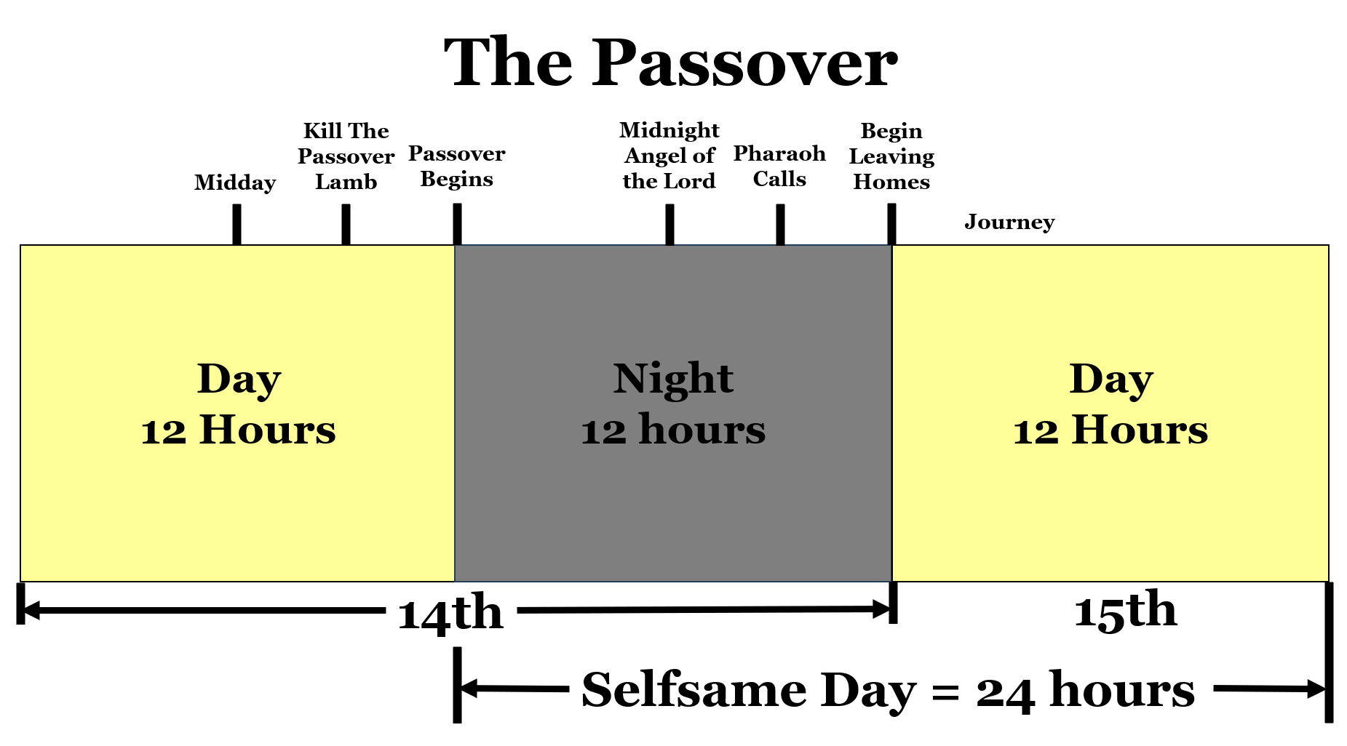
Again, look closely there. The passover lamb is killed in the evening about the 9th hour of the day as Jesus is the Passover Lamb and he was killed in the evening being the 9th hour of the day. You can argue all you want about the definition of evening and instead you should go with the Bible.
The Passover Lamb had to be killed before the Passover Feast began. When Jesus was killed at the ninth hour, they had about three hours to get His body down off the cross before the Passover Feast began. Why? Because the Passover Feast is when the holy convocation, a Sabbath day, begins.
""John 19:31
The Jews therefore, because it was the preparation, that the bodies should not remain upon the cross on the sabbath day, (for that sabbath day was an high day,) besought Pilate that their legs might be broken, and that they might be taken away.""

The High Day or Special Sabbath Day
It was the preparation day for the passover meaning it was the day of the 14th. A sabbath day was coming, but it wasn't a typical weekly Sabbath day. We know a typical weekly Sabbath day begins in the morning as explained in Matthew 28:1 and Exodus 16:22-23. This high day is a special Sabbath day, a Feast Day, the Passover.
It's the preparation for the Passover so the Passover is this high day that's about to begin. They have to get the body of Jesus Christ down and buried before the Passover Feast begins at even. They had about 3 hours to do this.
The Passover begins at even on the 14th as you see there on the timeline. The people are in their homes with blood on their homes. They are partaking of the passover lamb. They are eating of the roasted flesh of the lamb. They are eating all of it. They are eating unleavened bread and bitter herbs. They have their loins girded, shoes on, and staff in hand. They are ready to leave.
At midnight, all the firstborn in the homes in Egypt without the blood of the passover lamb on their homes are killed. All of Egypt is crying. Pharaoh calls for Moses and Aaron by night. He tells them to rise up and get out of here. Get out. All of you. Go serve the Lord. He asks for their blessing and tells them to leave.
The Egyptians want them gone. Why? They say, "We be all dead men."

The Children of Israel Were Ready to Go
The children of Israel get ready to go. They take their dough before it was leavened. They take their kneading troughs with them. They borrowed of the Egyptians and spoiled them. The children of Israel come up out of Egypt on that selfsame day.
All of this uses only the Scriptures. We know the truth here.
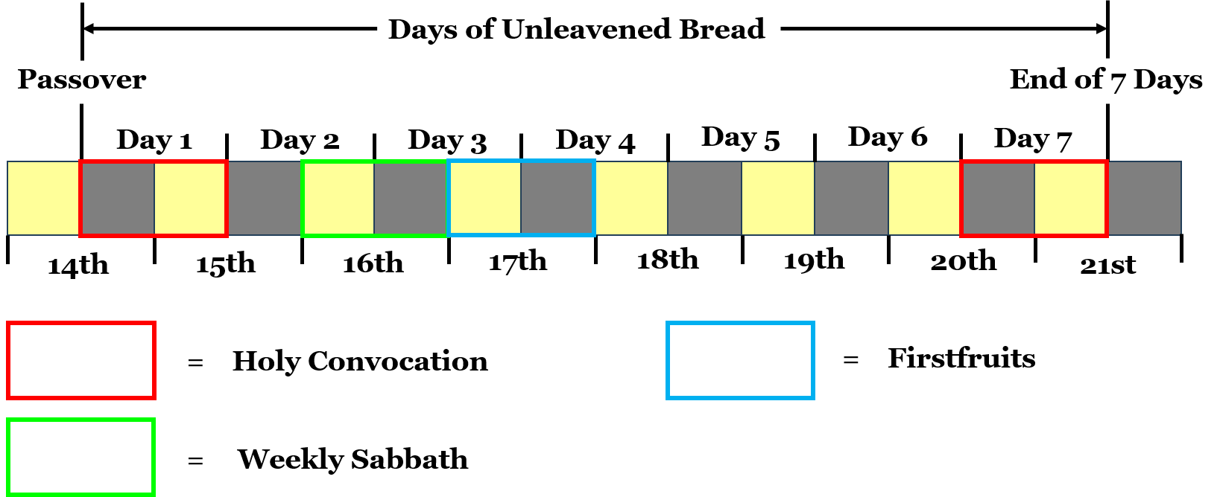
We have now gone over the Passover in detail. The Passover is a night to remember. The feast of unleavened bread begins on the 14th at even and continues into the day of the 15th when the children of Israel came up out of Egypt with their unleavened bread.
Let's pray.

